Week-1 SQL Command:
Creation of Tables:
CREATE TABLE CLIENT_MASTER (
CLIENTNO VARCHAR(6)
CONSTRAINT PK_CLIENT PRIMARY KEY
CONSTRAINT CK_CLIENTNO CHECK (CLIENTNO LIKE 'C%'),
NAME VARCHAR(20) NOT NULL,
ADDRESS1 VARCHAR(30),
ADDRESS2 VARCHAR(30),
CITY VARCHAR(15),
PINCODE int,
STATE VARCHAR(15),
BALDUE decimal(10,2)
);

CREATE TABLE PRODUCT_MASTER (
PRODUCTNO VARCHAR(6)
CONSTRAINT PK_PRODUCT PRIMARY KEY
CONSTRAINT CK_PRODUCTNO CHECK (PRODUCTNO LIKE 'P%'),
DESCRIPTION VARCHAR(15) NOT NULL,
PROFITPERC decimal(4,2) NOT NULL,
UNITMEASURE VARCHAR(10) NOT NULL,
QTYONHAND decimal(8) NOT NULL,
REORDERLVL decimal(8) NOT NULL,
SELLPRICE decimal(8,2) NOT NULL
CONSTRAINT CK_SELLPRICE CHECK (SELLPRICE <> 0),
COSTPRICE decimal(8,2) NOT NULL
CONSTRAINT CK_COSTPRICE CHECK (COSTPRICE <> 0)
);

CREATE TABLE SALESMAN_MASTER (
SALESMANNO VARCHAR(6)
CONSTRAINT PK_SALESMAN PRIMARY KEY
CONSTRAINT CK_SALESMANNO CHECK (SALESMANNO LIKE 'S%'),
SALESMANNAME VARCHAR(20) NOT NULL,
ADDRESS1 VARCHAR(30) NOT NULL,
ADDRESS2 VARCHAR(30),
CITY VARCHAR(20),
PINCODE int,
STATE VARCHAR(20),
SALAMT decimal(8,2) NOT NULL
CONSTRAINT CK_SALAMT CHECK (SALAMT <> 0),
TGTTOGET decimal(6,2) NOT NULL,
YTDSALES decimal(6,2) NOT NULL,
REMARKS VARCHAR(60)
);

CREATE TABLE SALES_ORDER (
ORDERNO VARCHAR(6) PRIMARY KEY
CHECK (ORDERNO LIKE 'O%'),
CLIENTNO VARCHAR(6),
ORDERDATE DATE,
DELYADDR VARCHAR(25),
SALESMANNO VARCHAR(6),
DELYTYPE CHAR(1)
CHECK (DELYTYPE IN ('P','F')),
BILLEDYN CHAR(1)
CHECK (BILLEDYN IN ('Y','N')),
DELYDATE DATE,
ORDERSTATUS VARCHAR(10)
CHECK (ORDERSTATUS IN ('In Process','Fulfilled','Backorder','Cancelled')),
FOREIGN KEY (CLIENTNO) REFERENCES CLIENT_MASTER(CLIENTNO),
FOREIGN KEY (SALESMANNO) REFERENCES SALESMAN_MASTER(SALESMANNO)
);

CREATE TABLE SALES_ORDER_DETAILS (
ORDERNO VARCHAR(6),
PRODUCTNO VARCHAR(6),
QTYORDERED INT,
QTYDISP INT,
PRODUCTRATE DECIMAL,
PRIMARY KEY (ORDERNO, PRODUCTNO),
FOREIGN KEY (ORDERNO) REFERENCES SALES_ORDER(ORDERNO),
FOREIGN KEY (PRODUCTNO) REFERENCES PRODUCT_MASTER(PRODUCTNO)
);
Insertions:
INSERT INTO CLIENT_MASTER VALUES
('C00001', 'Ivan Bayross', 'A/14 Worli', 'Near Park', 'Mumbai', 400054, 'Maharashtra', 15000),
('C00002', 'Sanjay Mehta', 'B/10 Connaught', 'Block A', 'Delhi', 110001, 'Delhi', 12000),
('C00003', 'Nisha Kaur', 'C/22 FC Road', 'Opp Mall', 'Pune', 411001, 'Maharashtra', 9000),
('C00004', 'Rohit Sharma', 'D/50 MG Road', 'HSR Layout', 'Bangalore', 560001, 'Karnataka', 18000),
('C00005', 'Aarti Shah', 'E/5 Anna Nagar', '2nd Street', 'Chennai', 600001, 'Tamil Nadu', 14000);

INSERT INTO PRODUCT_MASTER VALUES
('P00001', 'T-Shirt', 5.5, 'Piece', 200, 50, 350.00, 250.00),
('P00002', 'Jeans', 8.0, 'Piece', 150, 40, 900.00, 700.00),
('P00003', 'Trousers', 6.0, 'Piece', 300, 60, 750.00, 500.00),
('P00004', 'Pull Overs', 7.5, 'Piece', 100, 30, 1100.00, 850.00),
('P00005', '1.44 MB Drive', 4.5, 'Piece', 50, 20, 1500.00, 1200.00);
INSERT INTO SALESMAN_MASTER VALUES
('S00001', 'Aman', 'A/14', 'Worli', 'Mumbai', 400002, 'Maharashtra', 3000.00, 100.00, 50.00, 'Good'),
('S00002', 'Ravi Kumar', 'B/22', 'Andheri', 'Mumbai', 400053, 'Maharashtra', 5000.00, 150.00, 80.00, 'Average'),
('S00003', 'Sneha Iyer', 'C/10', 'Baner', 'Pune', 411045, 'Maharashtra', 4500.00, 120.00, 90.00, 'Excellent'),
('S00004', 'Vikas Rao', 'D/18', 'HSR', 'Bangalore', 560102, 'Karnataka', 3500.00, 80.00, 60.00, 'Good'),
('S00005', 'Neha Singh', 'E/55', 'T Nagar', 'Chennai', 600017, 'Tamil Nadu', 3200.00, 90.00, 70.00, 'Very Good');
INSERT INTO SALES_ORDER VALUES
('O19001', 'C00001', '2002-07-12', 'Mumbai', 'S00001', 'F', 'N', '2002-07-20', 'In Process'),
('O19002', 'C00002', '2002-08-10', 'Delhi', 'S00002', 'P', 'Y', '2002-08-15', 'Fulfilled'),
('O19003', 'C00003', '2002-09-05', 'Pune', 'S00003', 'F', 'N', '2002-09-12', 'Backorder'),
('O19004', 'C00004', '2002-07-22', 'Bangalore', 'S00004', 'P', 'Y', '2002-07-28', 'Cancelled'),
('O19005', 'C00005', '2002-10-02', 'Chennai', 'S00005', 'F', 'N', '2002-10-10', 'In Process');
INSERT INTO SALES_ORDER_DETAILS VALUES
('O19001', 'P00001', 10, 8, 350.00),
('O19001', 'P00003', 5, 5, 750.00),
('O19002', 'P00004', 3, 3, 1100.00),
('O19003', 'P00003', 7, 6, 750.00),
('O19005', 'P00004', 2, 1, 1100.00);
Select Commands:
  - select name from CLIENT_MASTER;
o/p:
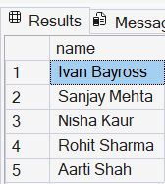
1.2: select name from CLIENT_MASTER where CITY='Mumbai';
o/p:
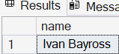
1.3: SELECT * from product_master where sellprice > 2000 AND sellprice < 5000;
o/p:

1.4: SELECT name, city, state FROM client_master WHERE state !='Maharashtra';
o/p:
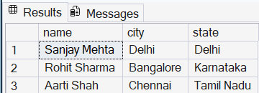

1.5: SELECT * from client_master where clientno IN ('C0001','C0002');
o/p:

1.6: UPDATE product_master set sellprice = 1150.50 where description = '1.44 MB Drive';
o/p:
1.7: DELETE FROM client_master WHERE clientno = 'C0005';
o/p:
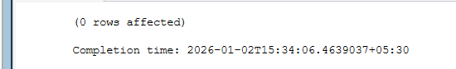

1.8: SELECT * from client_master where city LIKE '_a%';
o/p:
1.9: SELECT COUNT(*) AS product_count from product_master where sellprice >= 1500;
o/p:
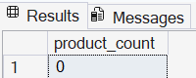
1.10: SELECT qtyordered,qtydisp,(qtyordered - qtydisp) AS balancedqty from sales_order_details;
o/p:
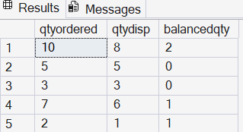

2.Alter Commands:
2.1: ALTER TABLE client_master ADD CONSTRAINT pk_clientno PRIMARY KEY (clientno);
o/p: Already client_no is primary key in client_master table

2.2: alter table client_master add phone_no varchar(30);
o/p:
2.3: ALTER TABLE product_master ALTER COLUMN description varcahr(15) NOT NULL;
ALTER TABLE product_mastern ALTER COLUMN profitperc DECIMAL(4,2) NOT NULL;
ALTER TABLE product_master ALTER COLUMN sellprice DECIMAL(8,2) NOT NULL;
ALTER TABLE product_master ALTER COLUMN costprice DECIMAL(8,2) NOT NULL;
o/p: 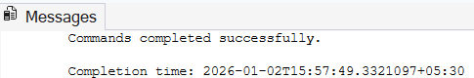

2.4: ALTER TABLE client_master ALTER COLUMN name varchar(60);
o/p:updated
2.5: ALTER TABLE client_master DROP COLUMN pincode;
o/p:command completed
Descriptive Questions:

1. Recursive Relationship
A Recursive relationship is when a table is related to itself, meaning a record in the table refers to another record in the same table.
Example: An employee table where one employee manages another employee.

2.Composite Key
A composite key is a primary key made up of two or more columns used together to uniquely identify a record.
Example:(orderno,productno) together form the primary key in a sales order details table.

3.LIKE Operator with Pattern Matching
The like operator is used to search for data that matches a specified pattern using wildcards.
Example: SELECT * FROM client_master WHERE city LIKE 'M%';

4.DROP TABLE Command
The drop table command permanently deletes a table along with all its data and structure.
Example: DROP TABLE client_master;

5.Full Outer Join
A full outer joinreturns all records from both tables, matching rows where possible and showing NULLs where there is no match.
Example: SELECT * FROM table1 FULL OUTER JOIN table2 ON table1.id = table2.id;
3. JOIN Commands:
3.1: select distinct p.description from CLIENT_MASTER c
join sales_order s
ON c.clientno = s.clientno
join SALES_ORDER_DETAILS sd on sd.ORDERNO=s.ORDERNO
join product_master p
ON sd.productno = p.productno
where c.NAME='Ivan Bayross';
o/p:
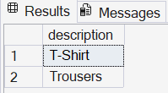
3.2: select p.description,sd.qtyordered from SALES_ORDER s
join sales_order_details sd on s.orderno=sd.orderno
join PRODUCT_MASTER p on p.PRODUCTNO=sd.productn where MONTH(s.ORDERDATE)=MONTH(getdate());
o/p:
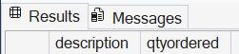
3.3: select p.PRODUCTNO,P.description from PRODUCT_MASTER p
join SALES_ORDER_DETAILS sd on sd.PRODUCTNO=p.PRODUCTNO
group by p.PRODUCTNO,p.DESCRIPTION having count(sd.ORDERNO)>1;
o/p:
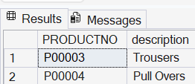

3.4: select c.NAME from CLIENT_MASTER c
join SALES_ORDER s on s.CLIENTNO=c.CLIENTNO
join SALES_ORDER_DETAILS sd on sd.ORDERNO=s.ORDERNO
join PRODUCT_MASTER p on p.PRODUCTNO=sd.PRODUCTNO
where p.DESCRIPTION='Trousers';
o/p:
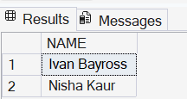

3.5: select s.orderno,p.productno,p.description,sd.qtyordered from sales_order s
join SALES_ORDER_DETAILS sd on sd.ORDERNO=s.ORDERNO
join PRODUCT_MASTER p on p.PRODUCTNO=sd.PRODUCTNO
where p.DESCRIPTION='Pull Overs' and sd.QTYORDERED<5;
o/p:
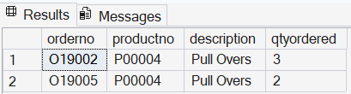

Subqueries:

4.1: select productno,description
from PRODUCT_MASTER
where PRODUCTNO not in(select PRODUCTNO from SALES_ORDER_DETAILS);

o/p:
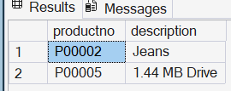

4.2:
select name,address1,address2,city,state from client_master
where clientno = (select clientno from sales_order where orderno='O19001');
o/p:
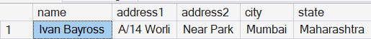

4.4:
select name from client_master where clientno IN (select clientno from sales_order where orderdate<'2002-05-01');

o/p:
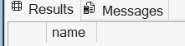
General Queries:
5.1: select datename(weekday,'2012-02-11')+','+
datename(month,'2012-02-11')+','+
cast(day('2012-02-11') as varchar) +','+
cast(year('2012-02-11') as varchar) as system_date;
o/p:
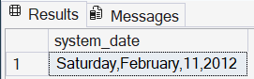

5.2: select format(baldue,'$99,999.99') as balance_due from client_master;
o/p:
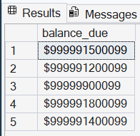
5.3:
select 'Salesman Aman sold goods of 50 while given target was 100.' as message;
o/p:
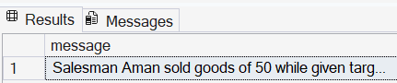
5.4:
select datediff(year,'2005-04-11',GETDATE()) as age;
o/p:
